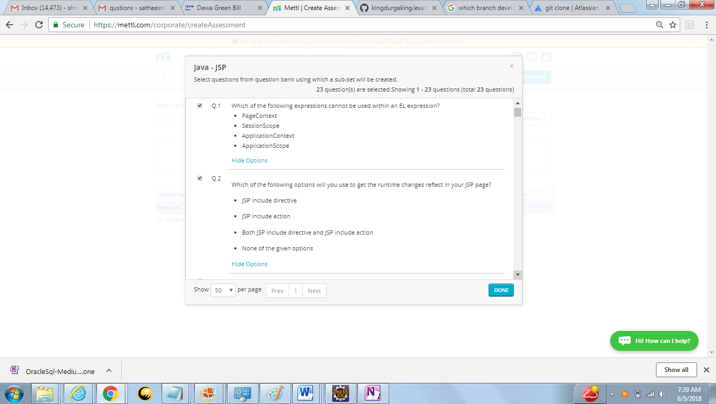

Q1 – Answer is Application Context

<https://docs.oracle.com/cd/E19798-01/821-1841/gjddd/index.html>

Q2- Jsp include Actions

<http://www.java67.com/2016/01/6-difference-between-include-directive-and-include-action-in-jsp.html>

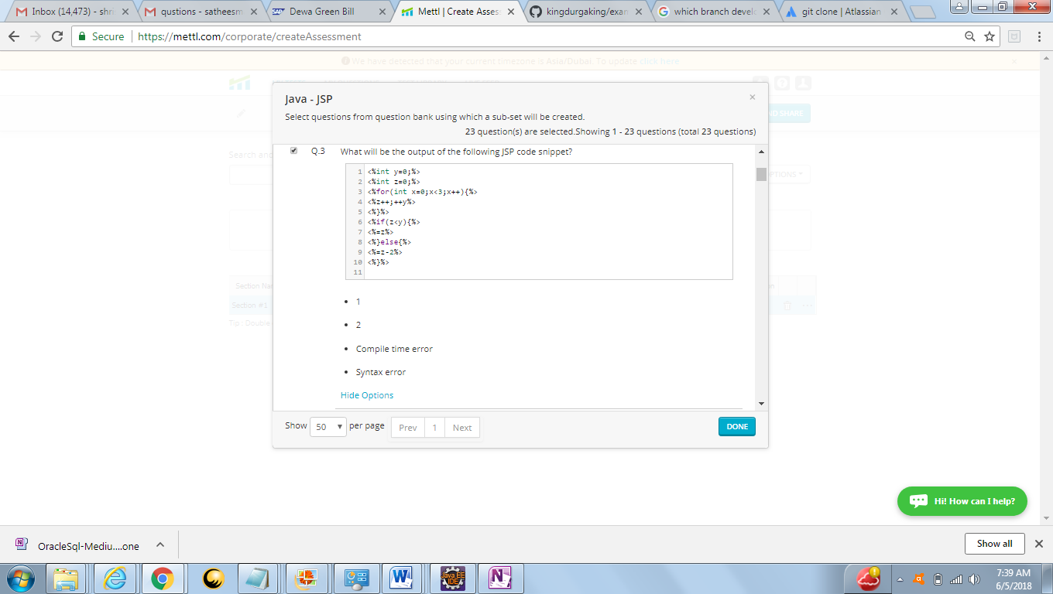

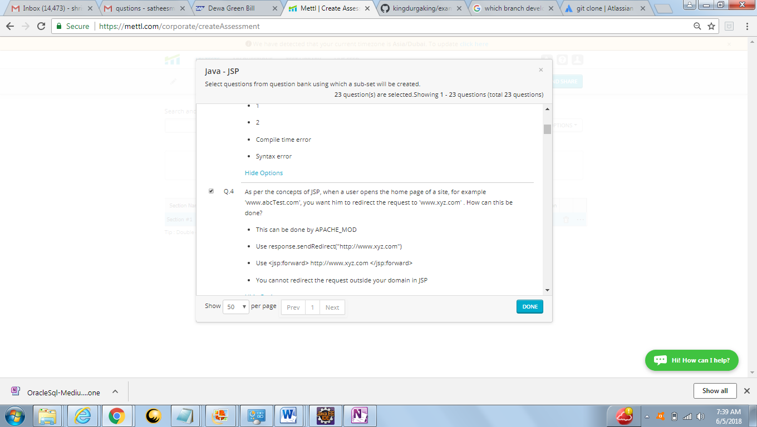

Q4 –Answer Use response.sendrediret(“http://www.xyz.com”)

<https://www.javatpoint.com/sendRedirect()-method>

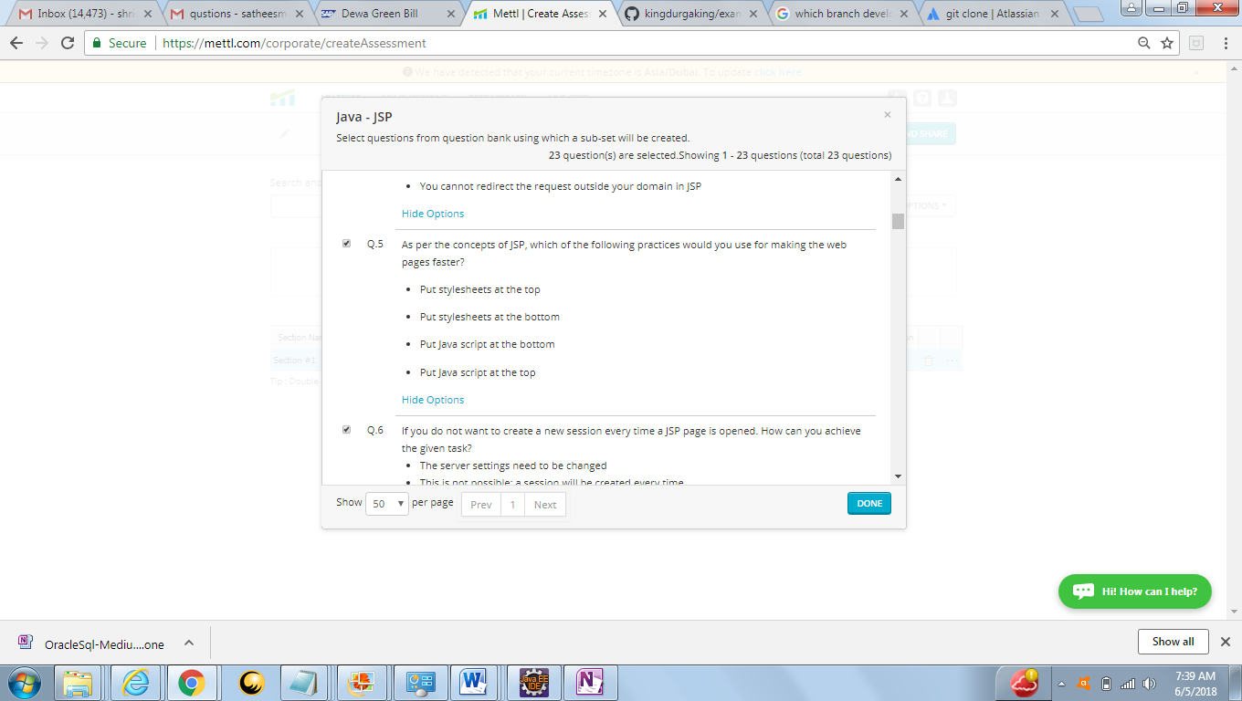

Q5 answer –put java script at bottom

<https://teamtreehouse.com/community/best-practice-where-to-include-your-script-tags>

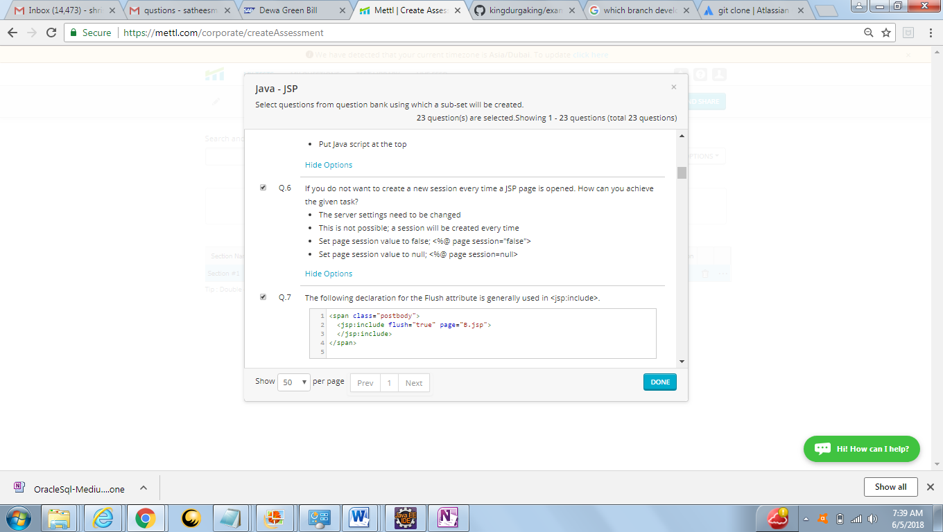

Q6 Answer –<%@ page session="false" %>

<https://stackoverflow.com/questions/5515729/why-set-a-jsp-page-session-false-directive>

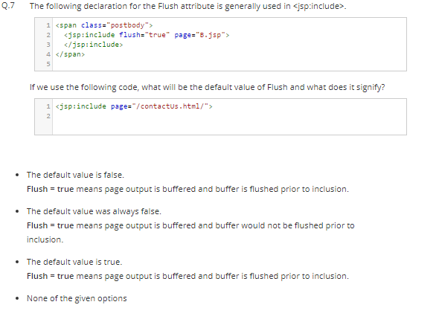

Q 7 Answer –default Value is true

<https://coderanch.com/t/484149/java/flush-true-jsp-include-tag>

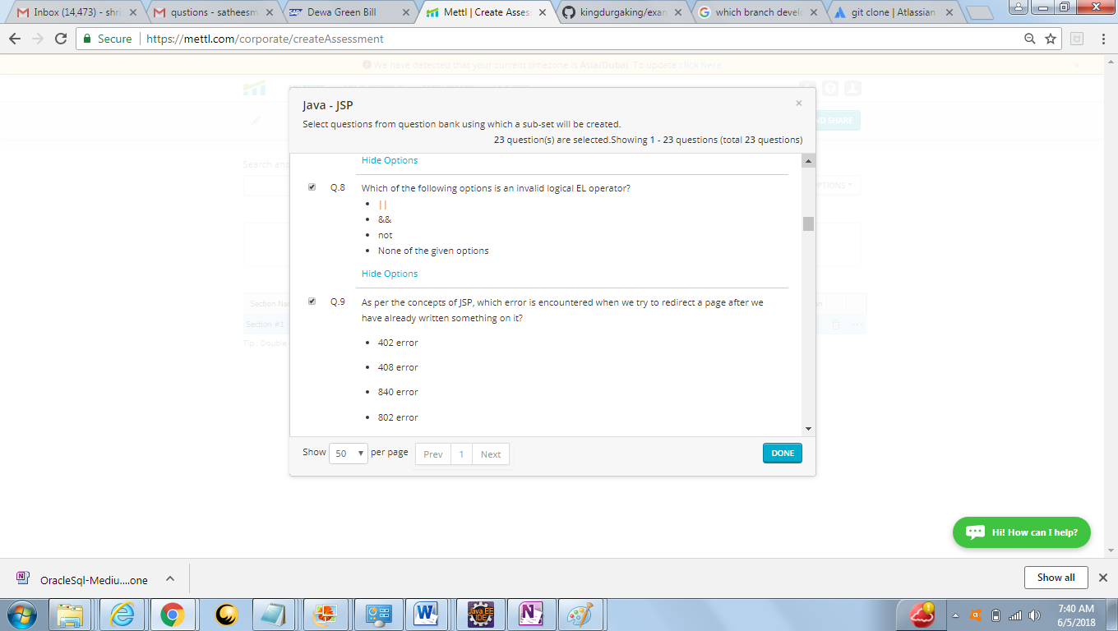

Q8 Answer – None of the above

<https://docs.oracle.com/javaee/6/tutorial/doc/bnaik.html>

Q9 Answer -408

<https://en.wikipedia.org/wiki/List_of_HTTP_status_codes>

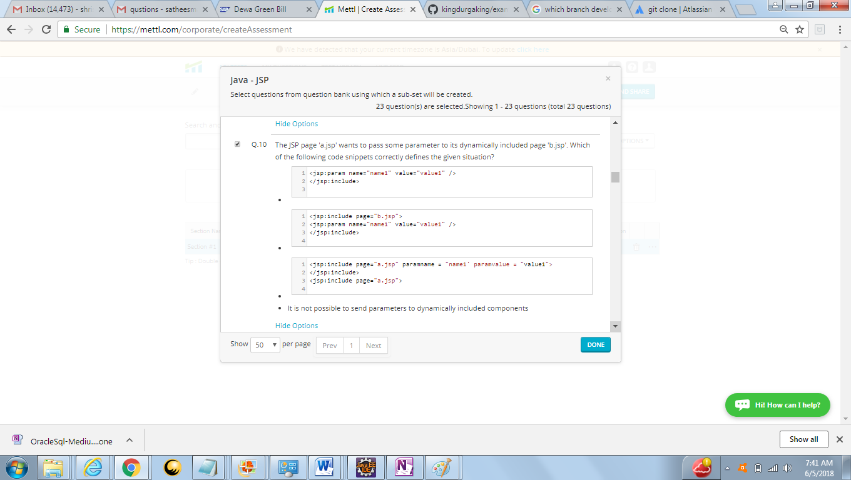

Q10 Answer – B

<https://stackoverflow.com/questions/3698068/jsp-include-with-parameters-usage>

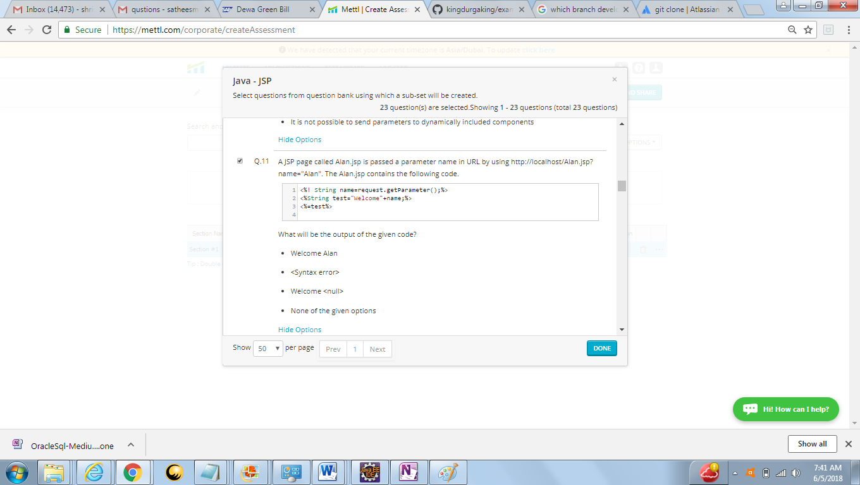

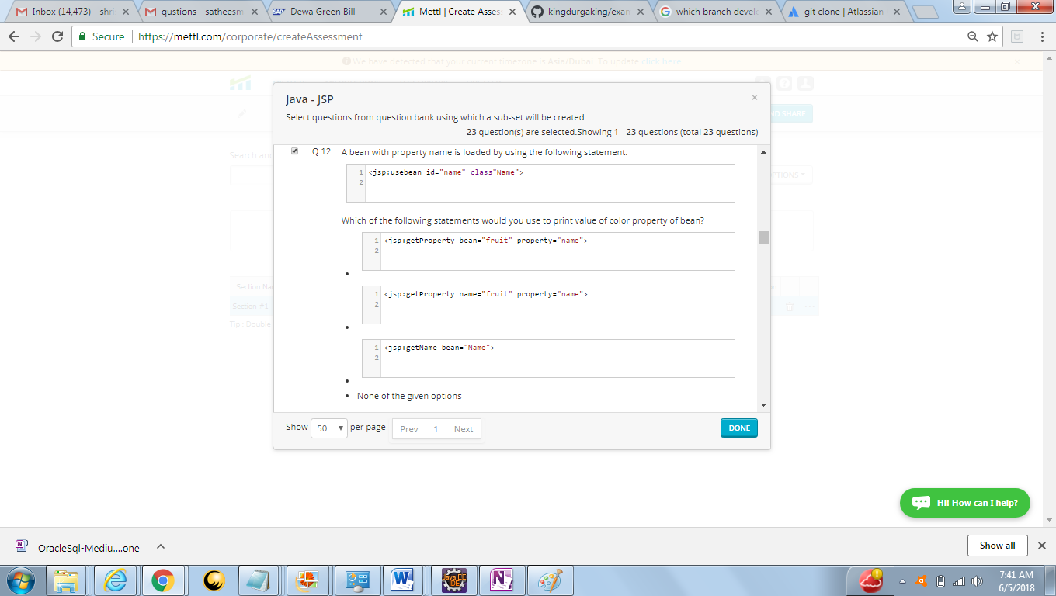

1. Q12 – None of the given options
2. <jsp:getProperty name="instanceOfBean" property="propertyName" />

<https://www.javatpoint.com/jsp-setProperty-and-jsp-getProperty-action-tag>

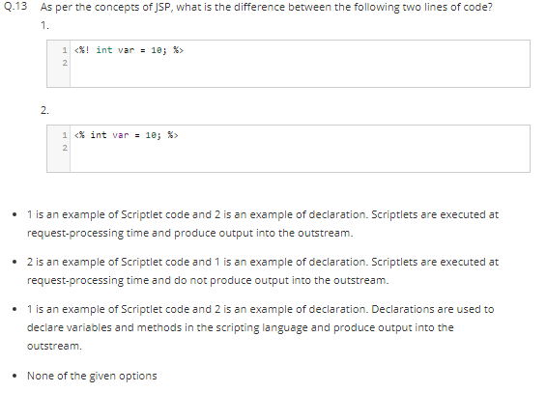

13 Answer Option 2

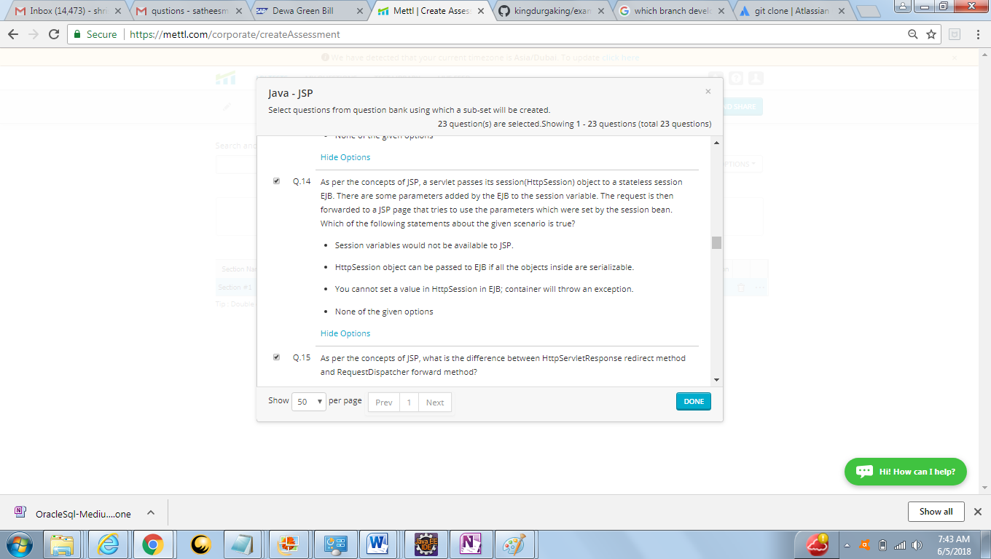

Answer – B we can pass the session object to EJB

<https://coderanch.com/t/318559/java/session-variable-stateless-session-bean>

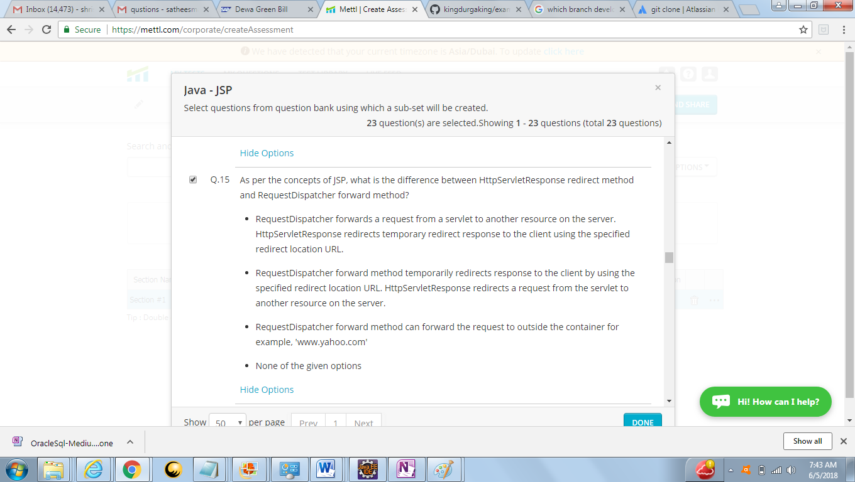

Answer –options A

<https://stackoverflow.com/questions/7220241/whats-the-difference-between-requestdispatcher-forward-and-httpservletrespons>

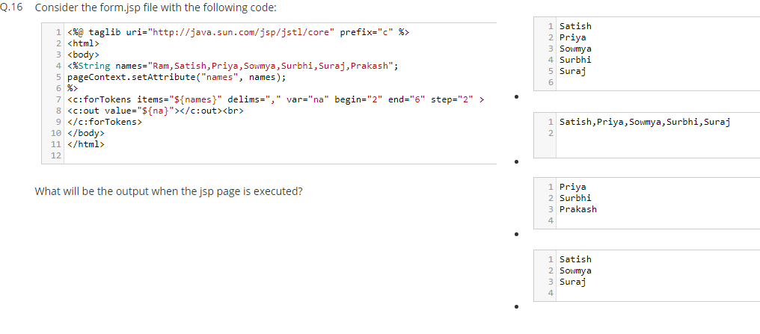

Not sure need to check

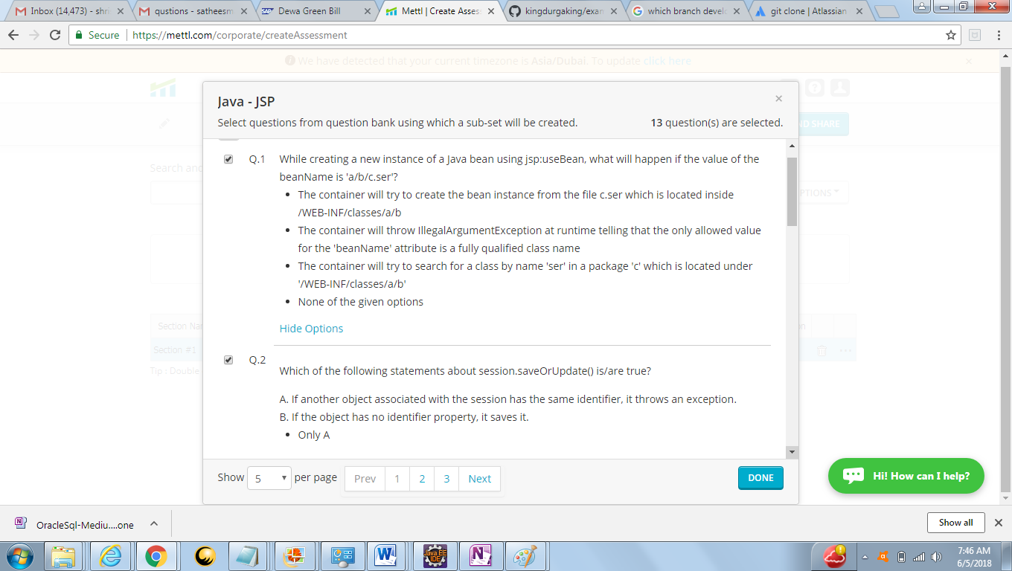

Answer – option A

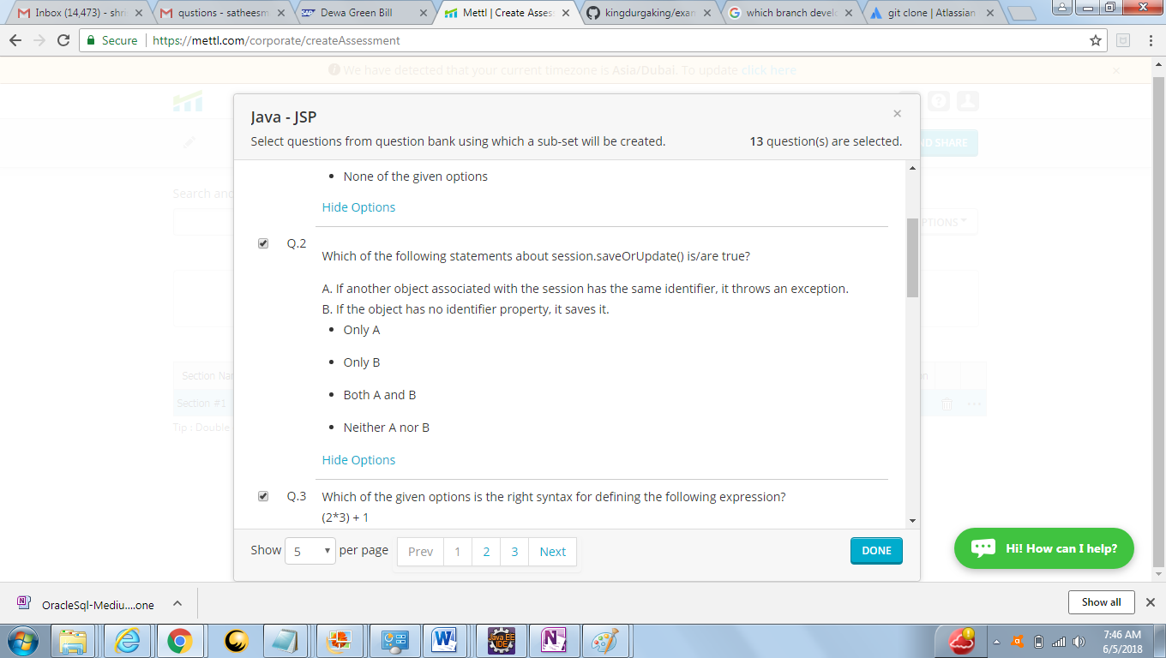

Answer - B

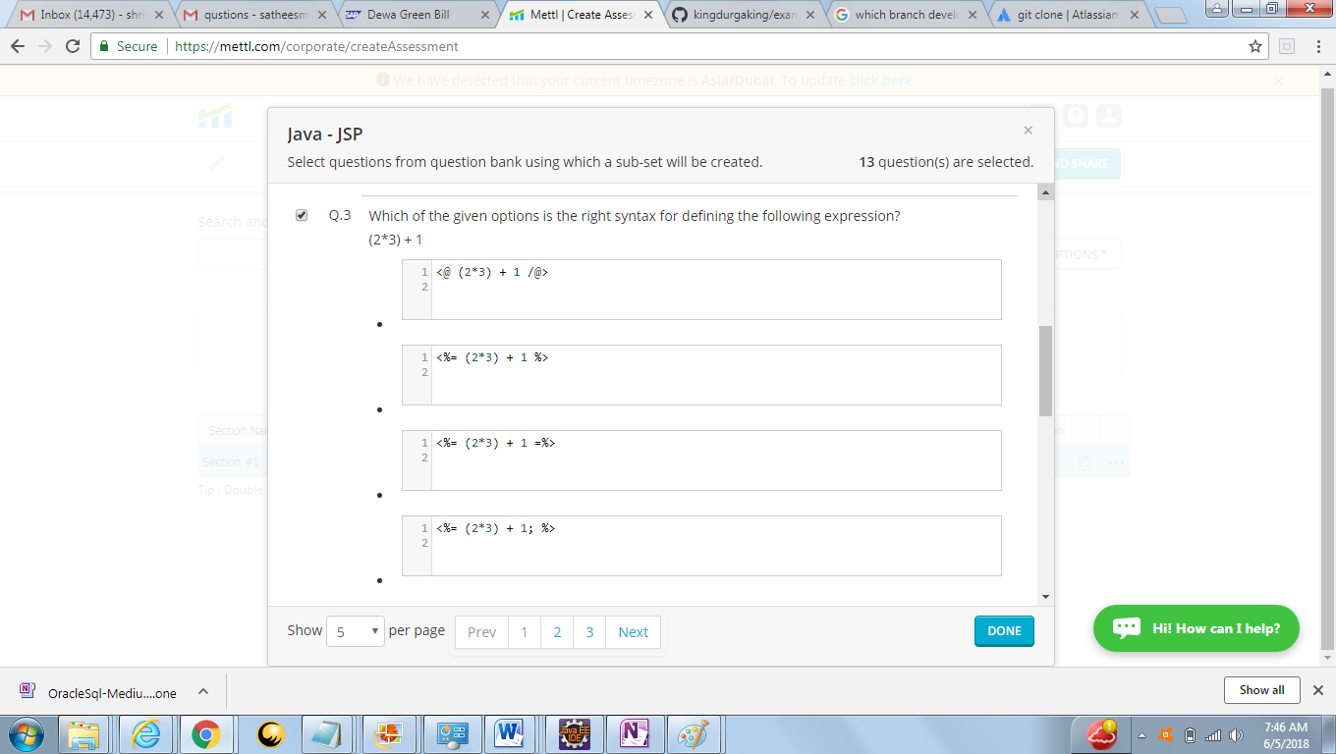

Answer -- B

<https://www.javatpoint.com/jsp-expression-tag>

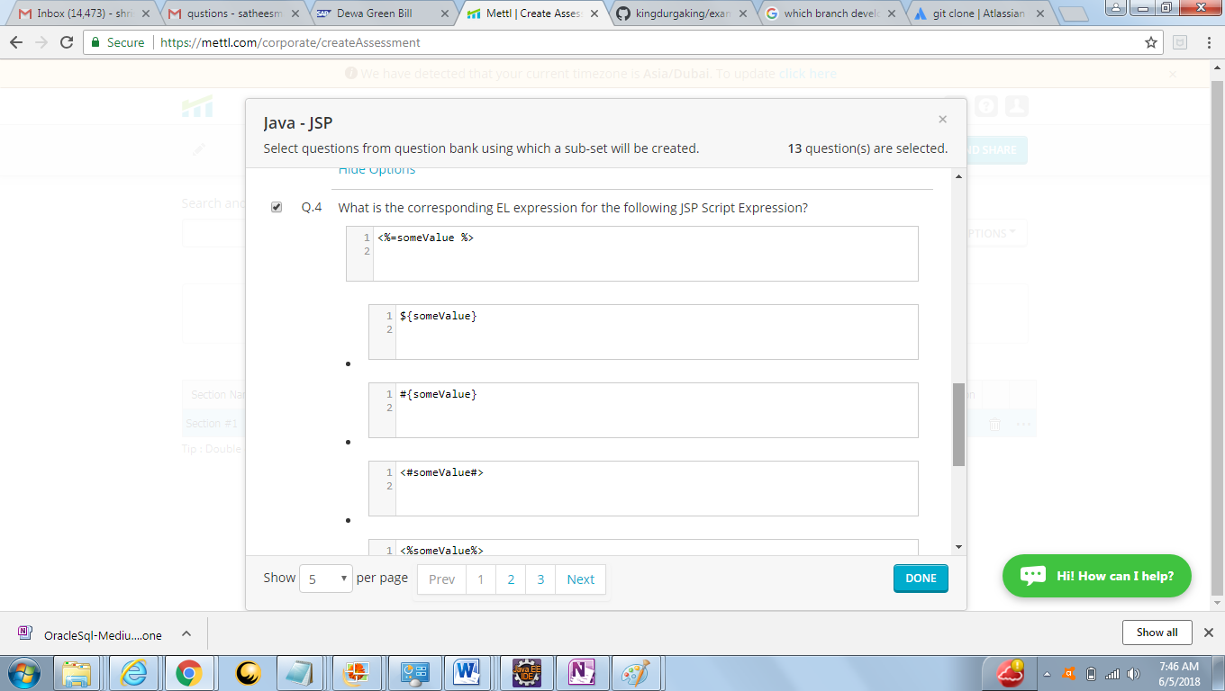

Answer –B

<https://www.tutorialspoint.com/jsp/jsp_expression_language.htm>

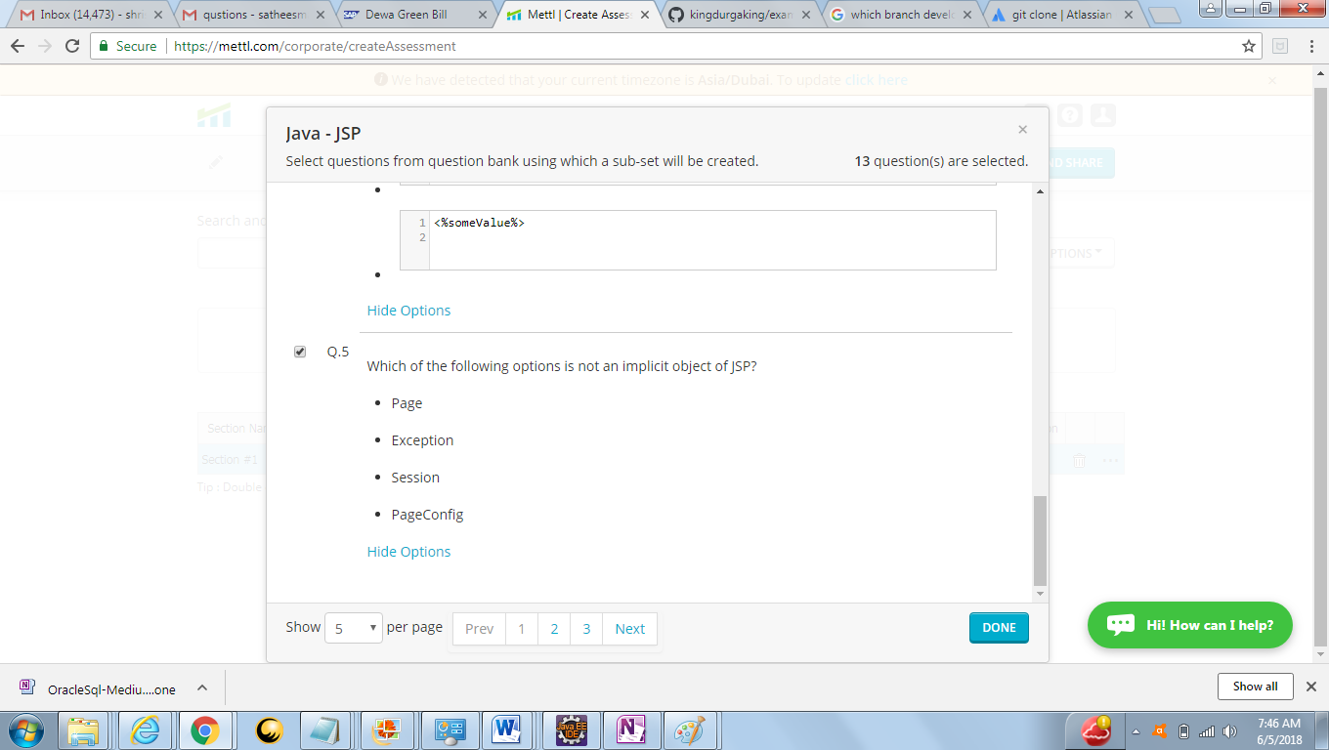

Answer : D

<https://www.javatpoint.com/jsp-implicit-objects>

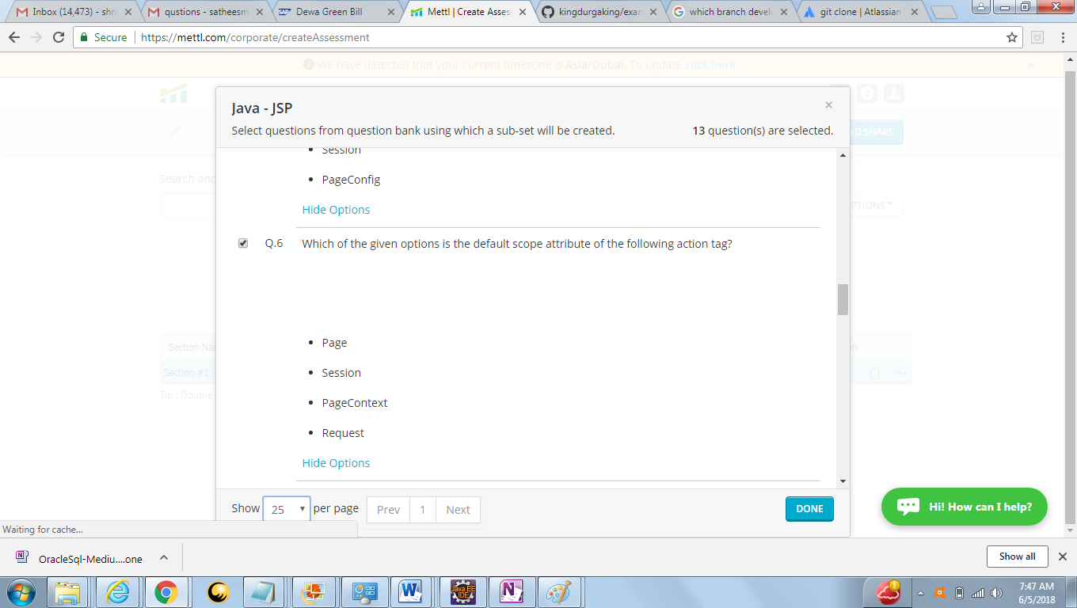

Answer – A Page

<https://stackoverflow.com/questions/36039806/what-is-the-default-value-of-scope-attribute-in-jstl-tags>

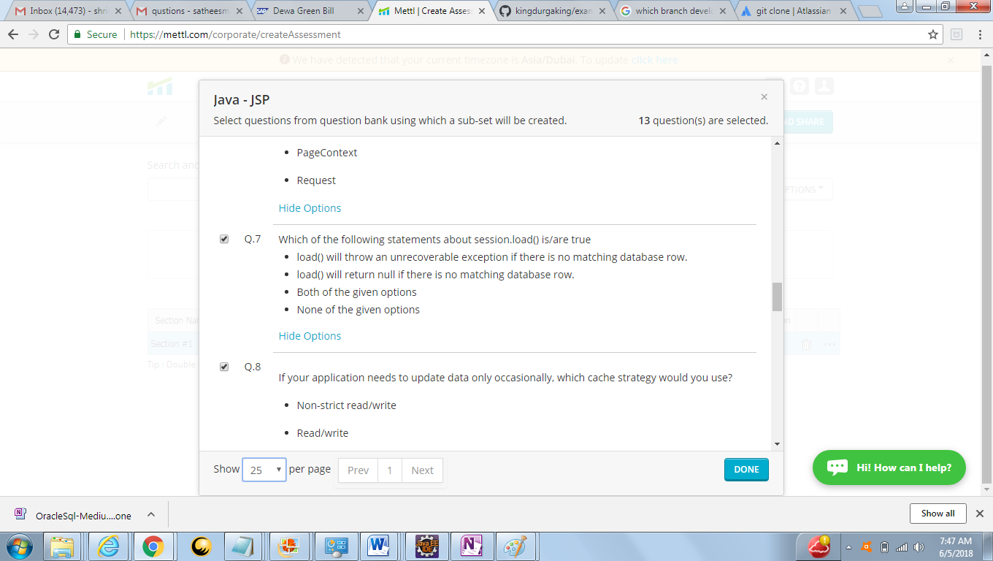

Q7 –Answer is A (Exception will throw)

<https://www.mkyong.com/hibernate/different-between-session-get-and-session-load/>

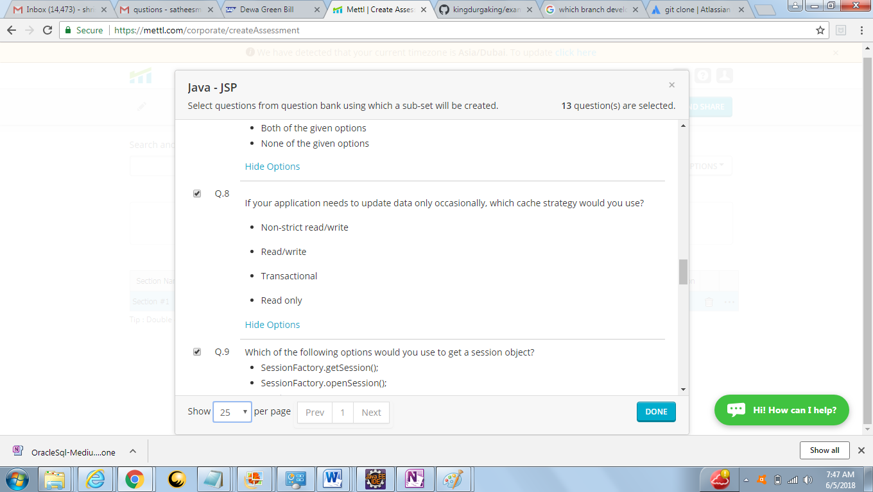

Q8 Answer – Option A

<https://stackoverflow.com/questions/1837651/hibernate-cache-strategy>

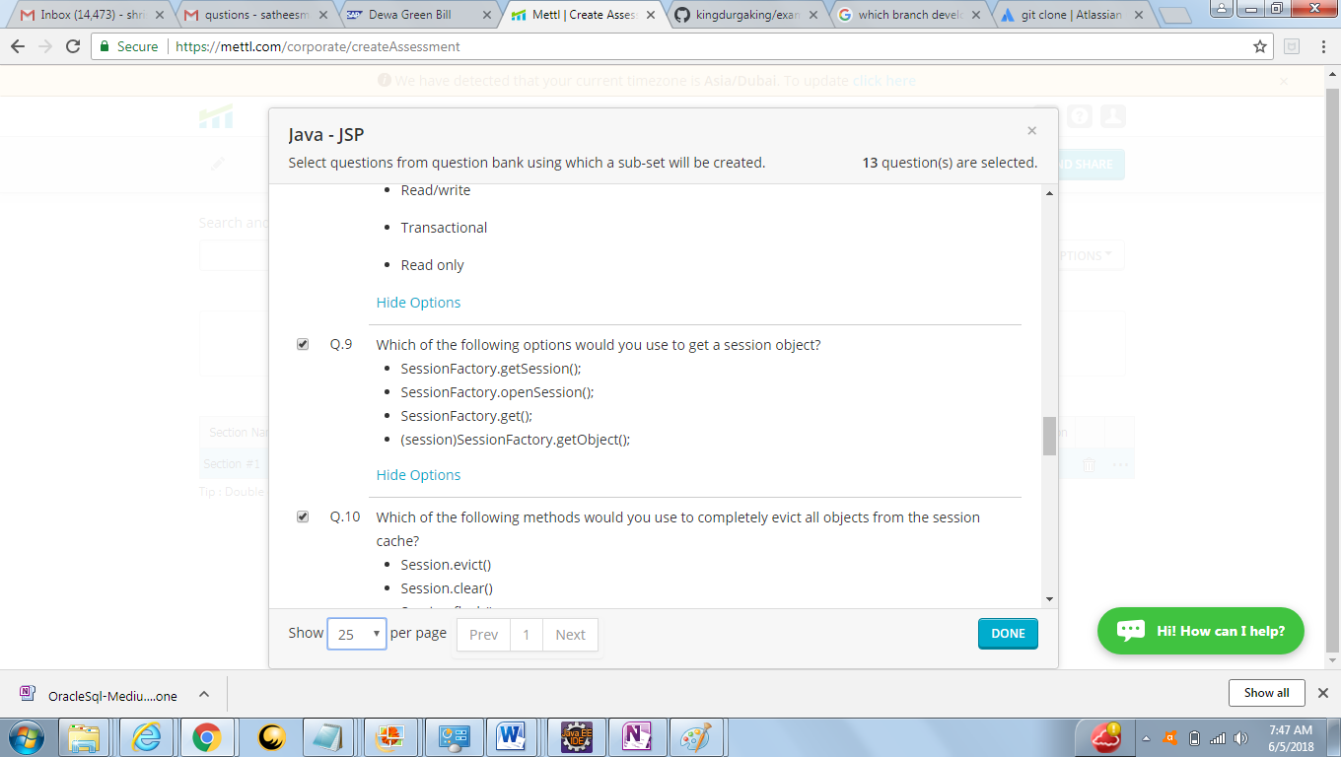

Q9. Answer --- B open session

<https://www.journaldev.com/3522/hibernate-sessionfactory>

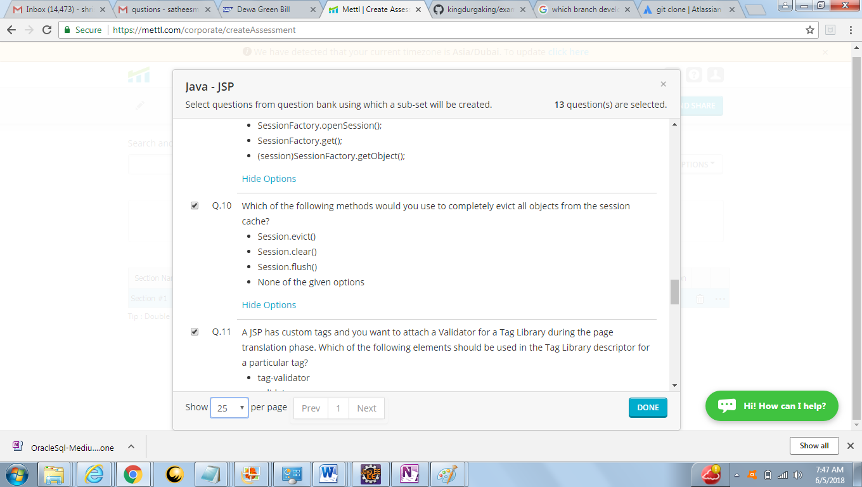

Q10 Answer B – clear

<https://stackoverflow.com/questions/44773732/what-is-difference-between-evict-and-clear-methods-in-hibernate>

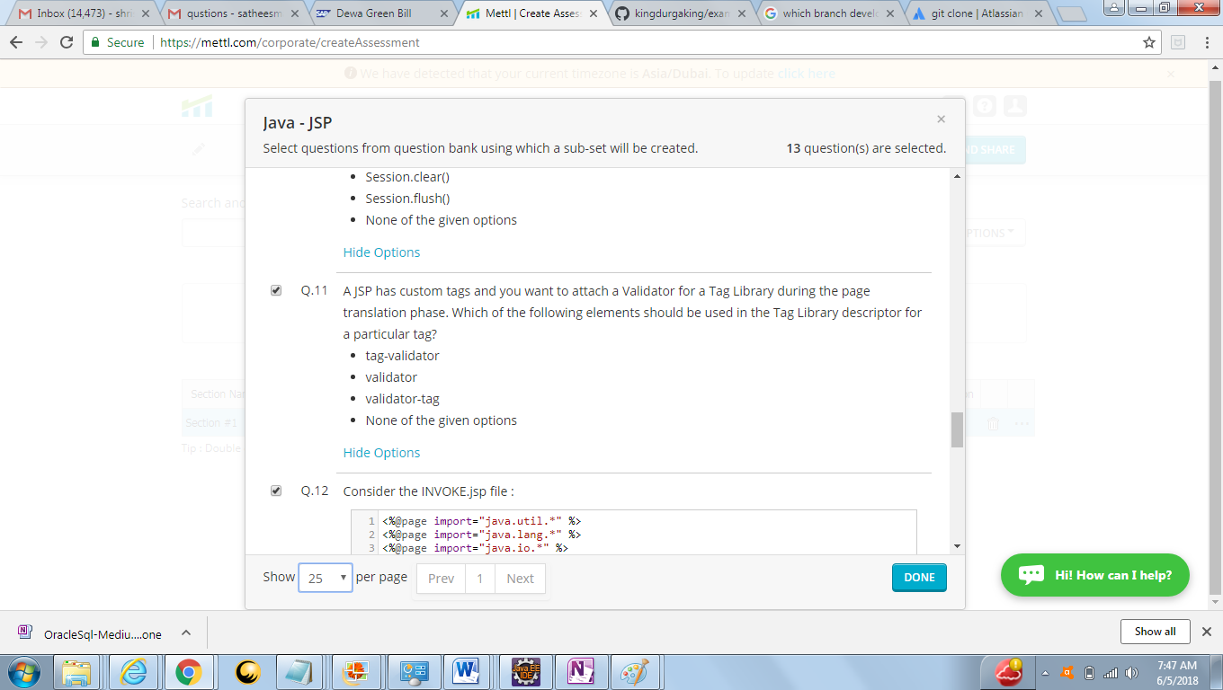

Answer B –**validator**

<https://docs.oracle.com/javaee/5/tutorial/doc/bnamu.html#bnamx>

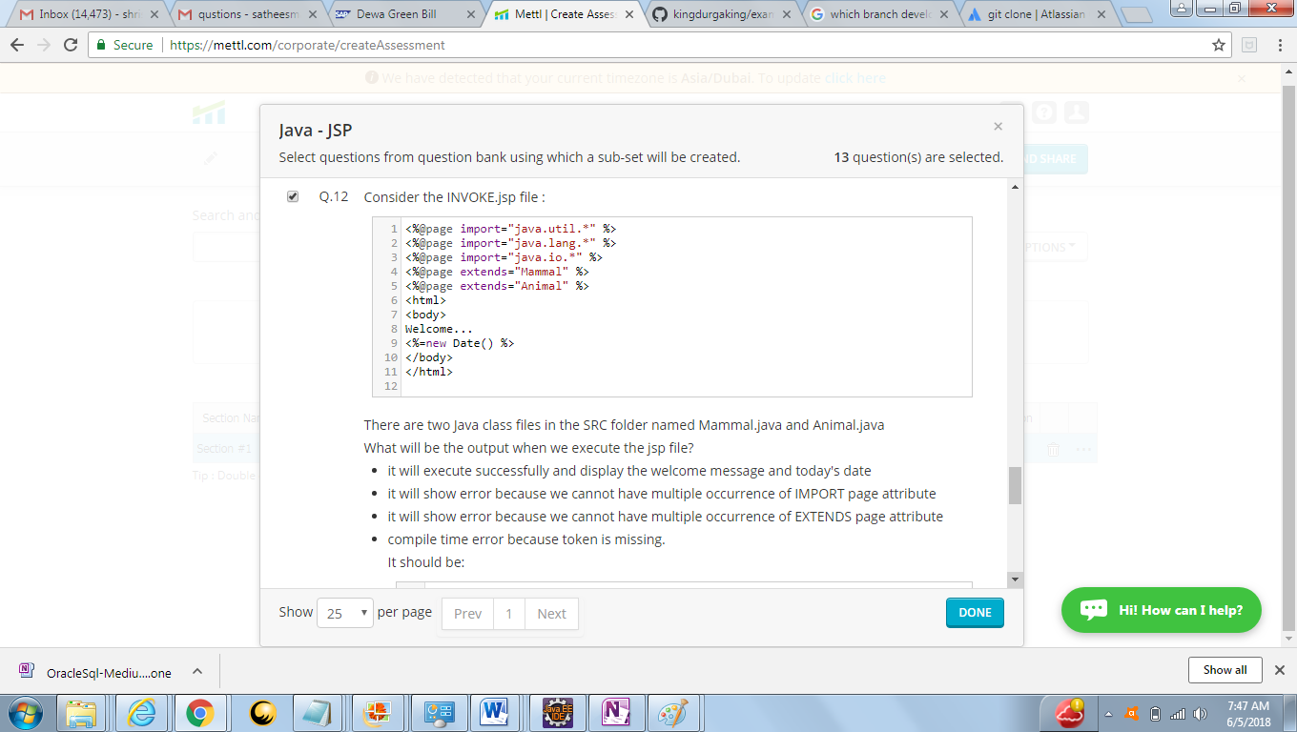

Answer - C (Multiple Extends)